CHAPTER-1
INTRODUCTION

1. INTRODUCTION
Internal combustion engines provide Supply incredible drivability and sturdiness, with in extra of 250 million high way transportation automobiles in the US relying on them. Alongside gasoline or diesel, they likewise use sustainable or optionally available powers (e.g., propane, petroleum gas, or ethanol). They can likewise be joined with cross breed electric powered energy trains to amplify mileage or module crossover electric powered frameworks to expand the scope of aggregate electric powered automobiles. [1]

1.1 The Performance of Internal Combustion

Combustion, likewise known burning, it is the basic chemical system of releasing power from a gasoline and air combination. In an inner combustion engine (ICE), the ignition and combustion of the fuel occurs inside the engine itself. Then the engine in part converts the electricity from the combustion to paintings. The engine includes a fixed cylinder and a transferring piston. The piston is driven by the through combustion gases, which in turn rotates the crankshaft. Finally, via a system of gears in the powertrain, this motion drives the vehicle’s wheels.

In production, the types of internal combustion are the spark ignition gasoline engine and the compression ignition diesel engine. Mostly of 4-stroke cycle engines, that means four piston strokes wanted to complete a cycle. The cycle consists of four wonderful tactics: consumption, compression, combustion and power stroke, and exhaust. Spark ignition gasoline and compression ignition diesel engines range in how they deliver and ignite the fuel. In a spark ignition engine, the gasoline is blended with air after which inducted into the cylinder at some point of the intake manner. After the piston compresses the gas-air mixture, the spark ignites it, inflicting combustion.

The enlargement of the combustion gases pushes the piston throughout the energy stroke. In a diesel engine, simplest air is inducted into the engine after which compressed. Diesel engines then spray the gasoline into the new compressed air at a appropriate, measured fee, causing it to ignite.

1.2 IMPROVING COMBUSTION ENGINES

Over the ultimate 30 years, research and development has helped producers lessen ICE emissions of criteria pollution, which include nitrogen oxides (NOx) and particulate count number (PM) by using greater than ninety nine% to conform with EPA emissions standards. Research has additionally brought about improvements in ICE overall performance (horsepower and 0-60 mph acceleration time) and performance, supporting manufacturers maintain or growth fuel economy.

Learn greater approximately our superior combustion engine research and improvement efforts focused on making internal combustion engines greater electricity efficient with minimum emissions. Internal combustion engines offer great drivability and sturdiness, with extra than 250 million dual carriageway transportation vehicles in the US counting on them. Along with gas or diesel, they also can utilize renewable or opportunity fuels (e.g., natural fuel, propane, biodiesel, or ethanol).

They also can be blended with hybrid electric powered powertrains[2] to increase fuel economy or plug-in hybrid electric structures to extend the variety of hybrid electric powered cars.
1.3 Fuel injection system
Fuel injection [3] is the advent of gas in an inner combustion engine, most typically automotive engines, through the manner of an injector.
All diesel engines use gasoline injection by using design. Petrol engines can use fuel direct injection, wherein the gasoline is directly brought into the combustion chamber, or oblique injection where the gas is mixed with air earlier than the consumption stroke.
On petrol engines, gas injection changed carburetors from the Eighties onward. The number one difference among carburetion and gas injection is that fuel injection atomizes the fuel thru a small nozzle underneath excessive pressure, even as a carburetor is based on suction created via consumption air multiplied thru a Venturi tube to attract the gas into the airstream.
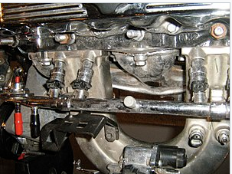
Fig 1.1
Main Objectives
The functional targets for gasoline injection structures can vary. All proportion the important assignment of providing fuel to the combustion manner, however it's miles a layout choice how a selected system is optimized. There are numerous competing goals along with:
• Power output
• Fuel efficiency
• Emissions performance
• Running on opportunity fuels
• Reliability
Benefits
Benefits of fuel injection include smoother and more constant brief throttle reaction, together with at some point of quick throttle transitions, easier cold beginning, greater correct adjustment to account for extremes of ambient temperatures and modifications in air stress, extra strong idling, decreased upkeep needs, and better fuel performance.
It also dispenses for a separate mechanical choke, which on carburetor-ready automobiles have to be adjusted as the engine warms up to regular temperature. Furthermore, on spark ignition engines, (direct) fuel injection has the advantage of being able to facilitate stratified combustion which has not been viable with carburetors.
It is best with the appearance of multi-point fuel injection positive engine configurations which includes inline five-cylinder fuel engines have end up more viable for mass production, as traditional carburetor arrangements with single or twin carburetors cannot offer even gas distribution between cylinders, unless a extra complicated individual carburetor in step with cylinder is used.
1.4 Direct Fuel Injection System
Common rail direct gasoline injection[4] is an immediate fuel injection gadget for diesel engines. It capabilities a excessive-strain (over 100 bar or 10 MPa or 1,500 psi) gas rail feeding solenoid valves, as opposed to a low-stress gasoline pump feeding unit injectors (or pump nozzles). Third-technology not unusual rail diesels now function piezoelectric injectors for expanded precision, with gasoline pressures up to two, 500 bar (250 MPa; 36,000 psi).
High pressure injection gives you power and gasoline consumption blessings over earlier decrease pressure fuel injection, by means of injecting gas as a bigger quantity of smaller droplets, giving a far better ratio of floor region to extent. This offers progressed vaporization from the floor of the fuel droplets and so extra efficient combining of atmospheric oxygen with vaporized fuel delivering more entire combustion.
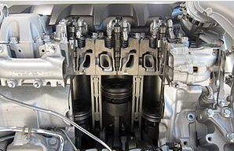
Fig 1.2
History
The commonplace rail system prototype turned into evolved in the overdue Nineteen Sixties through Robert Huber of Switzerland, and the era become in addition evolved by Dr. Marco Ganser at the Swiss Federal Institute of Technology in Zurich, later of Ganser-Hydromag AG (est.1995) in Oberägeri.
The First success use in a manufacturing vehicle commenced in Japan with the aid of the mid-Nineties. Dr. Shohei Itoh and Masahiko Miyaki of the Denso Corporation[5], a Japanese automobile-parts producer, evolved the common rail fuel device for heavy-duty cars and became it into sensible use on their ECD-U2 common rail system hooked up on the Hino Ranger truck and bought for trendy use in 1995. Denso claims the first industrial excessive-stress common rail device in 1995.
Modern commonplace rail systems, even though operating on the same principle, are ruled by using an engine control unit, which opens each injector electrically instead of robotically. This changed into considerably prototyped in the 1990s with collaboration among Magneti Marelli, Centro Ricerche Fiat, and Elasis[6]. After research and improvement with the aid of the Fiat Group, the design changed into acquired by using the German organization Robert Bosch GmbH for finishing touch of improvement and refinement for mass production. In hindsight, the sale seemed to be a strategic error for Fiat, as the brand new era proved to be incredibly profitable. The organization had little preference but to promote Bosch a licence, as it became in a negative financial country at the time and lacked the resources to finish development on its personal. In 1997, they prolonged its use for passenger cars. The first passenger vehicle to apply the common rail machine became the 1997 version Alfa Romeo 156 2.4-L JTD, and later that same year, Mercedes-Benz brought it of their W202 version[7].
Common rail engines used in marine and locomotive programs for some time. The Cooper-Bessemer GN-8 (circa 1942) is an example of a hydraulically operated commonplace rail diesel engine, also known as a changed not unusual rail[8].
Vickers pioneered the usage of not unusual rail injection in submarine engines. Vickers engines with the commonplace rail gasoline system were first utilized in 1916 within the G-magnificence submarines. It used four plunger pumps to supply a strain up to three,000 kilos in keeping with square inch (210 bar; 21 MPa) every 90° of rotation to maintain the gasoline pressure adequately consistent inside the rail. Fuel delivery to man or woman cylinders may be shut off by way of valves within the injector lines[9].Doxford Engines used a not unusual rail gadget of their adversarial-piston marine engines from 1921 to 1980, wherein a multicylinder reciprocating gasoline pump generated a strain round six hundred bars (60 MPa; 8,700 psi), with the fuel being saved in accumulator bottles. Pressure manipulate turned into performed with the aid of an adjustable pump discharge stroke and a "spill valve"[10]. Camshaft-operated mechanical timing valves have been used to deliver the spring-loaded Brice/CAV/Lucas injectors, which injected via the facet of the cylinder into the chamber fashioned between the pistons[11]. Early engines had a couple of timing cams, one for ahead strolling and one for astern. Later engines had two injectors according to cylinder, and the final collection of constant-stress turbocharged engines turned into outfitted with four injectors according to cylinder. This gadget turned into used for the injection of each diesel and heavy gasoline oil (600cSt heated to a temperature close to 130°C)[12].
Applications
The commonplace rail device is suitable for all types of street motors with diesel engines, starting from metropolis vehicles (which include the Fiat Panda) to executive vehicles (inclusive of the Audi A8). The foremost suppliers of present day common rail structures are Robert Bosch GmbH, Delphi, Denso, and Siemens VDO (now owned through Continental AG)[13].
1.5 Working Principle of CRDI
Solenoid or piezoelectric valves make viable quality electronic manage over the gas-injection time and quantity, and the higher stress that the commonplace rail technology makes available offers higher fuel atomisation. To lower engine noise, the engine's electronic manage unit can inject a small amount of diesel just earlier than the primary injection occasion ("pilot" injection), therefore reducing its explosiveness and vibration, as well as optimising injection timing and quantity for versions in gas pleasant, bloodless starting, and so forth[14]. Some superior commonplace rail gas structures carry out as many as 5 injections in step with stroke.Common rail engines require a very quick to no heating-up time, relying on the ambient temperature, and convey lower engine noise and emissions than older systems[15].
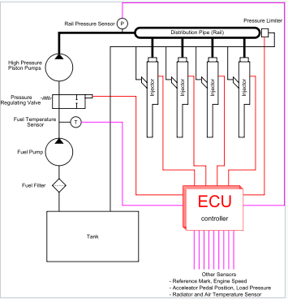
Fig 1.3
Diesel engines have historically used various forms of gasoline injection. Two not unusual types encompass the unit-injection device and the distributor/inline-pump systems. While those older systems offer accurate gasoline quantity and injection timing manage, they are constrained with the aid of several factors:
• They are cam driven, and injection stress is proportional to engine speed. This typically means that the highest injection strain can best be accomplished at the highest engine pace and the maximum possible injection stress decreases as engine velocity decreases. This courting is authentic with all pumps, even those used on commonplace rail structures. With unit or distributor structures, the injection strain is tied to the immediately strain of a unmarried pumping occasion and not using a accumulator, for this reason the relationship is extra prominent and troublesome.
• They are limited in the variety and timing of injection occasions that may be commanded at some stage in a single combustion event. While more than one injection activities are viable with those older structures, it is a whole lot more tough and costly to reap.
• For the standard distributor/inline machine, the begin of injection takes place at a predetermined pressure (frequently called pop stress) and ends at a predetermined strain. This characteristic results from "dumb" injectors inside the cylinder head which open and close at pressures decided by way of the spring preload carried out to the plunger within the injector. Once the pressure within the injector reaches a predetermined level, the plunger lifts and injection starts.
In not unusual rail systems, a high-stress pump stores a reservoir of gasoline at high strain — up to and above 2,000 bars (200 MPa; 29,000 psi). The time period "not unusual rail" refers back to the reality that every one of the gas injectors are provided through a commonplace gasoline rail that is nothing greater than a strain accumulator where the gas is saved at high stress. These accumulator materials more than one gasoline injectors with high-stress gasoline. This simplifies the purpose of the excessive-stress pump in that it most effective needs to preserve a goal stress (both routinely or electronically managed). The gasoline injectors are normally ECU-controlled. When the fuel injectors are electrically activated, a hydraulic valve (which includes a nozzle and plunger) is automatically or hydraulically opened and gas is sprayed into the cylinders at the desired stress. Since the fuel strain electricity is stored remotely and the injectors are electrically actuated, the injection strain at the start and quit of injection may be very near the pressure within the accumulator (rail), for this reason generating a square injection fee. If the accumulator, pump, and plumbing are sized well, the injection pressure and price will be the same for each of the multiple injection events.

CHAPTER-2
LITERATURE REVIEW

2. LITERATURE SURVEY
2.1 INTERNAL COMBUSTION ENGINE
2.1.1 COMPRESSION IGNITION ENGINE
The modeling of the impact of exhaust fuel recirculation on Homogenous price Compression Ignition (HCCI) in Diesel Engine has been investigated. The performance and emission discount of the engine have been a critical factor of view from take a look at rate compression ignition. Moreover, the greater adoption of the diesel engine has been inhibited by way of the growing public awareness on pollutants as well as the rising price related to the high quantity of particulate count (PM) and oxides of nitrogen (NOx) of its emission. The growth of compression-ignition (CI) engine gasoline efficiency observed with the aid of lower emissions has endorsed extensive studies at the enhancements of the diesel engine. In this paper, we describe the current progress finished in the research of advanced combustion and fuels to improve the gas performance of diesel or CI engines. An Exhaust fuel Recirculation (EGR) gadget changed into organized to be equipped inside the engine. They have a look at on the possibility of EGR software in decreasing the engine-out NOx emissions in a heavy-responsibility diesel engine has been performed by using employing a polished 1D fluid-dynamic engine model generated in raise software program equipment and the manipulate of engine cycle parameters. Realization displays that the engine with a gap valve of exhaust fuel recirculation 0.3 and a compression ratio of 20 generated the very best volumetric performance[1].With an increasing number of critical issues of environmental pollutants, the technologies of diesel engine are confronted with extremely good demanding situations on decreasing emissions to fulfill stringent emission law. because the foremost pollutants emitted by using diesel engines, it becomes a totally vital trouble to reduce the quantity of NOx and PM. primarily based on pre-remedy and post-treatment concepts, the paper specially introduces numerous technology to lessen the emissions of NOx and PM. those technologies encompass CO 2 in-cylinder injection, the usage of oxygenated fuels[2]. There are restricted studies to expose the effect of nearby diesel gasoline kinds specifically in Kurdistan place of performed to evaluate the impact of different styles of diesel fuel having one of a kind cetane quantity, which can be from Kirkuk, Dura, Basra refineries and with ethanol mixed diesel gasoline 8%. The other samples of diesel gasoline are from crude oil in TaqTaq oil field in Koya, refined in both Kar and Bazyan refineries. For this reason, the gasolines with one of kind values of cetane range have been examined in a direct injection diesel engine at variable speed and cargo. The have a look at showed that the awareness emission of co, NOx and HC are decreased by using 6%, 7% and 16%, respectively, while CO2 are increased by way of three% for fuel cetane number 50. The reason of decreasing emissions is because of complete combustion of those fuels. Result additionally display that Koya diesel gasoline gives the worst dangerous emissions of CO. The result shows that the exhaust emission of co is in general decreased with growing cetane range, and its price is increased at maximum engine torque for all engine speeds. Ethanol mixed gas with cetane range fifty-four gives minimal emission of CO at engine pace n= 2200 rpm. NOx emissions of the better cetane number gasoline are decreased by using 20% and co of this fuel is reduced to 58%. In general, the ethanol blended fuel gives slightly decrease HC and CO[3].A good way to enhance the plateau adaptability of CY4102BZLQ-A2A turbocharged diesel engine, the matching performances of the diesel engine with TB28 and HP60 turbochargers at one-of-a-kind altitudes (0 m, 2,000 m, 3,000 m, three,500 m, 4,000 m) have been investigated on the engine check bed for simulating excessive altitude (1ow atmosphere stress). Effects show that HP 60 turbocharger is greater suitable to fit the engine in phrases of engine overall performance, intake air traits, turbocharger rotational velocity etc. TB28 turbocharger is over velocity whilst the engine runs at three,500 m altitude and 2, 600 r/min rotational speed, whilst HP60 turbocharger is over velocity when the engine runs at 4,000 m altitude and a pair of,800 r/min rotational velocity. Irrespective of which turbocharger is selected to match the engine, the performance of the engine will become worse at specific extents. The consumption air go with the flow mass and the air-fuel ratio decrease through 7.1-10.5% and 7.2-10.3% respectively with altitude growing each 1,000 m. through evaluation with 0 m altitude, engine torque and strength at 4,000 m altitude decrease inside 1% and the particular gasoline consumption increases through three.2-three.5% on the maximum torque speed, at the same time as the engine torque and electricity decrease via 4.6-5.3% and 4.5-5.2% respectively and the specific gasoline intake will increase by way of 5.3-11.5% at higher and lower engine rotational pace[4].The16V280ZJ diesel engine is the energy unit of Chinese most important railway diesel locomotive. This newsletter has hooked up this diesel engine electron injection gadget's complete device version the use of the GT software. Then a chain of combustion cases of heavy duty D.I. diesel engine is calculated based on ordinary cut up injection modes. Simulation parameters are changed via contrast with given experimental consequences. Calculation consequences efficaciously proven the consequences on warmness release price with the aid of unique injection speed, gas distribution and pulse c program language period. Therefore, injection optimization underneath multi-injection mode is summarized[5].The 3-D fashions of the cylinder block of 4D25G Diesel Engine, have been modeled with pro/Engineer and simplified, factors were applied to mesh 3-D geometric fashions, after which the FEM model turned into constructed. Using the version, a modal analysis changed into carried out to get the basic vibration mode and the nature frequency of the cylinder block. via evaluation for consequences, we can analyze dynamic function of the cylinder block. it can provide the route wherein the vibration and noise could be further decreased through the structural development[7].The combustion procedure and emission traits in diesel engine specially rely on the mixture formation in cylinder. Spray function is a crucial factor which affects the combination formation and combustion process. In addition, nozzle hollow cone angle of the gasoline injector at once impact the spray characteristic. In this paper, float evolution manner, spray distribution, fuel/air ratio equivalence ratio distribution, temperature distribution and emissions formation are analyzed. The results display that: combination formation pleasant may be stepped forward if selecting the nozzle hole cone angle accurately, and consequently combustion manner could be advanced, and emissions can be decreased[8].Warmth launch rate is one of the crucial elements affecting diesel engine traits. This paper gives a diesel engine dynamics model primarily based on identification of heat release rate. on the spot engine speed and cylinder strain can be received via numerical simulation of air intake and exhaust houses, in-cylinder combustion process and crank rotational dynamics using the identity outcomes. Simulation consequences of the engine velocity and cylinder pressure nicely coincide with experimental ones for one-of-a-kind outside loads and nominal engine pace[9].Taking the YN4100QB diesel engines because the research object, acoustic power of the radiation noise from the floor of the engine has been tested and calculated, which utilizes the measuring technique of superficial acoustic strain levels based at the simulation system of atmospheric pressure. The engine's combustion noise, mechanical noise and inlet noise have additionally been efficiently separated with the test of the noise supply identity of diesel engines. All the measures are taken to probe into the influencing mechanism of atmospheric stress on combustion noise of DI-diesel engines. Comparisons are made about the difference of combustion noise in diesel engines to attain its version regulation with different altitudes[10].Main engine producers carry on investigations and R&D paintings to improve reliability and durability of internal combustion engines (ICE), especially, diesel engines. Diesel engine examination and testing are the main techniques for verifying manufacturing satisfactory of components and assembly components, gadgets and engine in whole, accuracy of assembling, correspondence of fundamental diesel engine characteristics to the requirements of technical specifications. The styles of diesel engine check approaches are regulated with the aid of the kingdom requirements (GOST) and worldwide standards (ISO), which outline the procedures for engine commissioning and requirements to engine overall performance standards. Manufacturers maintain to improve the development of engines and performance indicators even after their commissioning and installation. A modern diesel engine check procedure is a complicated and time-consuming system that can be compared with experimental studies. For that reason, automation systems for engine trying out (AST) are created. The needs for constant improvement of performance requirements of diesel engines raise the charges with respect to test procedures inside the route of improvement of new engine prototypes. Particularly, excessive fees are associated with a mismatch among a degree of automation of manufacturing and R&D works. Therefore, automation of test processes is one of the major desires to be completed which will enhance the extent of era at production and great of synthetic diesel engines [11].There are restricted studies to expose the effect of nearby diesel gasoline kinds specifically in Kurdistan place of performed to evaluate the impact of different styles of diesel fuel having one of a kind cetane quantity, which can be from Kirkuk, Dura, Basra refineries and with ethanol mixed diesel gasoline 8%. The other samples of diesel gasoline are from crude oil in TaqTaq oil field in Koya, refined in both Kar and Bazyan refineries. For this reason, the gasolines with one of kind values of cetane range have been examined in a direct injection diesel engine at variable speed and cargo. The have a look at showed that the awareness emission of co, NOx and HC are decreased by using 6%, 7% and 16%, respectively, while CO2 are increased by way of three% for fuel cetane number 50. The reason of decreasing emissions is because of complete combustion of those fuels. Result additionally display that Koya diesel gasoline gives the worst dangerous emissions of CO. The result shows that the exhaust emission of co is in general decreased with growing cetane range, and its price is increased at maximum engine torque for all engine speeds. Ethanol mixed gas with cetane range fifty-four gives minimal emission of CO at engine pace n= 2200 rpm. NOx emissions of the better cetane number gasoline are decreased by using 20% and co of this fuel is reduced to 58%. In general, the ethanol blended fuel gives slightly decrease HC and CO[12].The experiments of the emissions of diesel engine fueled with the pistache seed biodiesel diesel gas and methanol - diesel gas have been executed on YTR3105 diesel engine. The NOx emission and combustion characteristics of the engine fueled with the two styles of blend fuels have been investigated; the adiabatic flame temperature was calculated. The outcomes of burning delay, burning length and air-gasoline ratio on NOx emission have been mentioned. The consequences show that the NOx emission of the two kinds of fuels will increase with the growth of engine load. With the boom of the mixing ratio, the NOx emission of engine fueled with pistache seed biodiesel and the natural diesel engine are same to or barely boom. The NOx emission of methanol - diesel gas decreases with the boom of the mixing ratio. The adiabatic flame temperature of Methanol - diesel gas is a long way lower than the pistache seed biodiesel – diesel[13].The start system of multi-cylinder diesel engine has been experimental investigated on this paper. With a fixed injection period, the begin experiment is carried out with unique injection timing. Then, with hard and fast injection timing, the experiment of the starting moment is finished with extraordinary injection length. based at the above test records and the calculation approach, the matching approach for the transmission gadget is recommend as well as corresponding injection strategy[14].
2.1.1.1 COMMON RAIL DIRECT INJECTION
A rapid control prototyping primarily based on torque control algorithm the usage of V-cycle mode for common rail diesel engine used to be developed, and a torque prediction model used to be existing which along with a feed-forward suggest value engine mannequin and a feedback correction of error caused through the feed ahead model. Finally, experiments were carried out on check bench to confirm the control feasibility and reliability of the techniques and optimize the emissions, Experimental consequences showed that the predicted manage effects have been finished and the engine reached the EURO-III exhaust emission standard [15].In order to improve the gas consumption of hybrid electric vehicles, this paper focuses on the method that calibration of electronic manipulate systems for hybrid electric vehicles based on optimizing the low-load MAP in the ECU. Through examining and altering the engine manages strategy, this paper finds out this method to search the first-class fuel-efficient area. On the other hand, to resolve the trouble of changing the nation of diesel engine when the automobiles work on the low-load country is another reason of this method. And this paper takes more attention on the performance of the hybrid electric powered vehicles through enhancing the engine manipulate strategy and calibrating the MAP of this part. Using this system in hybrid experimental bench for hybrid system, numerous experiments had been carried out: built-in control of the financial system area, the engine rapidly start/stop control, BSG motor and engine torque manipulate technology research. The effects exhibit that after parameter optimization the frequent rail diesel engine well-known shows the aspects of speedy response, right smoothness and small speed overshoot. And in vehicles test, electricity provide in a field, everyday traffic, limp domestic control have been tested[16].Tougher law on exhaust emissions reduction, more power and mobility and less fuel consumption, has led to better call for the electronic engine control units for marine diesel engines. Electronically-controlled common-rail structures for marine diesel engine is introduced in the paper. Testing approach based totally on Hardware-in-the-loop(HIL) simulation is depicted in details. The precise HIL platform is established upon the NI products, while the mean cost engine model(MVEM) of marine diesel engine and its accessorial components are developed in MATLAB/Simulink environment. Software of Lab VIEW and Simulink are combined together with the Simulation Interface Toolkit. Implementation results show the feasibility of the unconventional solution, which will honestly play greater essential role in future marine engine controller development [17].
The manipulate strategies of frequent rail stress through regulating charge of coming into glide are studied. The manage circuit and solenoid valve are trial-manufactured. The stress of frequent rail managed by means of trial-manufactured solenoid valve is tested in test-bed. The results show that The opening time of Trial-manufactured solenoid valve is 1.1 ms, and its closing time is 0.9 ms. it can fulfill the requires of frequent rail system [18].The excessive stress common rail (HPCR) gasoline injection systems are broadly used in modern diesel engines. The control of the rail pressure will become challenging in transient method over the entire range of operating conditions. To efficaciously address this issue, a model-based rail strain controller (RPC) in the HPCR fuel injection device for diesel engines is proposed based totally on the dynamic feedforward manipulate algorithm, the static feed ahead manage algorithm and the commentary comments control algorithm. The dynamic feed forward control algorithm for the rail strain is designed based totally on the mathematical model. The static feed ahead control algorithm for the rail pressure is designed based on the look-up tables (curves and maps). The remark remarks manipulate algorithm for the rail strain is designed based totally on the linear lively disturbance rejection control (LADRC). The RPC is simulated and implemented in the ASCET software surroundings of ETAS GmbH and has been built-in to an in-house developed electronic manage unit (ECU) of HPCR diesel engines. Experimental validation of RPC has been carried out on a turbocharged V-8 HPCR diesel engine check bench. Experimental outcomes are furnished to verify the effectiveness of the proposed controller. From the experimental results, it is located that the RPC indicates a precise degree of tracking overall performance in a large vary of the engine running conditions [19].For improving power output, gas economy, and emissions of diesel engines, stress feedback science is introduced to electronic control excessive strain frequent rail system. In this paper, the geometry characteristic index in the stress difference curve is introduced after examining stress distinction curve; the relations of the pressure attribute indexes with injection parameter, output torque and NOx emission are researched by using simulation and testing method; the impact of simulation and checking out suggests that the characteristic index can replicate the center and output variable of diesel engine. By selecting radial basis feature (RBF) neural net, feedback variable module using the pressure characteristic index is structured; conversion to feedback variable from pressure characteristic index is performed. The check of electronic controlled injection using cylinder pressure remarks is carried out on the diesel engine equipped with high stress common rail system, trying out records suggests that introducing strain comments to digital controlled system can function closed-loop manipulate for NOx ; the engine emission control of common-rail diesel engine based on cylinder strain comments is feasible and effectively [20].The injection mass of common rail device is decided through rail pressure and injector energizing time. Under exclusive rail pressure, single injection experiments have been performed; beneath the identical rail stress two injections (preinjection and predominant injection) checks with various intervals have been carried out. According to the analysis of the results, find that at the start-up and end stages the injection rate becomes quicker with increasing rail stress and the injection characteristics for common-rail machine tends to rectangular jet. When the rail stress is low, the needle valve has sluggish response, and the fantastic go with the flow location of the injector radically influences the jet law. When the rail stress is improved, the valve's response pace will be extended remarkably and the injection rate is in most cases affected via the rail pressure. During a couple of injections the needle valve lift has affected on the mass of the primary injection extra than the rail strain fluctuations precipitated by means of pre-injection [21].Based on diesel engine geared up with common rail, the multi-injection strategies common rail diesel engine test bed is set up with NI take a look at system. In this test bed, the influences of optimized multi-injection strategies to diesel engine performances are studied. The check outcomes exhibit that by the usage of multi-injection strategies, the diesel engine exhaust temperature can minimize 50°C, and noises can minimize 15dB, and emission improve obviously [22].The project for the high speed direct injection (HSDI) diesel engines these days is to minimize dangerous emissions of diesel engines, such as particulate count (PM) and Nitrogen oxides (NOx), and enhance the fuel effectivity and power. To meet this challenge, extra accurate control of injection parameters such as the injection timing, injection rate, and injection volume is required. Compared with solenoid actuated injectors, the piezo actuated injectors can reduce the transition time for the start and end of the gasoline injection event, ensuing in extra accurate and quicker injections, and are step by step replacing the solenoid injectors. In this study, an electromechanical mannequin of a piezo injector is developed with MATLAB/Simulink. The piezo injector model consists of three subsystems: the piezoelectric stack actuator subsystem, the mechanical subsystem and the hydraulic subsystem. A lumped parameter electromechanical mannequin is used for describing the nonlinear conduct of the piezoelectric stack actuator. Different running prerequisites of the injection machine are modeled and tested. The mannequin has been used to furnish perception into the working prerequisites of the piezo injector and highlight the software to injection machine design [23].

2.1.2 SPARK IGNITION
The combustion procedure and emission traits in diesel engine specially rely on the mixture formation in cylinder. Spray function is a crucial factor which affects the combination formation and combustion process. In addition, nozzle hollow cone angle of the gasoline injector at once impact the spray characteristic. In this paper, float evolution manner, spray distribution, fuel/air ratio equivalence ratio distribution, temperature distribution and emissions formation are analyzed. The results display that: combination formation pleasant may be stepped forward if selecting the nozzle hole cone angle accurately, and consequently combustion manner could be advanced, and emissions can be decreased [24].
2.2 COMPUTATIONAL FLUID DYNAMICS ANALYSIS ON ENGINES
Multi-dimensional transient numerical simulation was carried out for low-temperature oxygen-enriched combustion method of 4100QBZL-2 diesel engine through the usage of CFD software program AVL-Fire and a simplified mannequin of n-heptane oxidation coupling. To set up combustion chamber mannequin and generate mesh with the ESE, in the computation process, FIRE will transfer and calculate the chemical kinetics mannequin in every cell. Adjusting component volume fraction in intake air with: 21% O 2 (atmosphere), 24% O 2 (oxygen-enriched combustion) and 24% O 2 /10% CO 2 (low temperature oxygen-enriched combustion), then the calculation could use them. The outcomes show: O 2 concentration 24% in contrast with 21% , the combustion fee is faster and the most strain upward jostle extra than 0.2 MPa relatively. Combustion with 24% O 2 /10% CO 2 intake air make the ignition time prolong to TDC, the maximum strain decreased to 10.7 MPa, the most temperature used to be 1548.4 K, which is decreased 60.2 K and completed low temperature oxygen-rich combustion comparing with air combustion. With discount of combustion temperature, NO emission is also decrease than the case of combustion air [25].Based on YD4A75-C3 electronic-controlled common rail diesel engine, the attribute of in-cylinder combustion used to be simulated. The research results confirmed that fuel vapor primarily is fashioned in the front of the jet spray, and then the notable section of gas is subtle to the combustion chamber wall, concave and clearance by using jet kinetic energy. In-cylinder height temperature region all most seems in the outer house of gas distribution, in the region oxygen content material is comparatively higher and burning charge is pretty higher. Due to unburned gas and combustion products absorbed extra volume of heat, and its distribution region also has distinctly greater temperature .NO generally is shaped in the particularly higher oxygen-rich place in the outer area of high temperature combustion flame, and Soot is fashioned in the high-temperature and fuel-rich region [26].To remedy the inaccurate injection volume hassle in more than one injections of high stress common rail injection system, in this paper, a simulation model of the machine is developed in AMESim environment, and the injection quantity fluctuation characteristics with respect to the dwell time between consecutive injections and pilot injection quantity are investigated. The outcomes show that injection extent fluctuates periodically and the fluctuation vary attenuates progressively with increasing dwell time. In addition, underneath the equal primary injection, the fluctuation amplitude of the gasoline injection volume increases with the expand of pilot injection quantity. Furthermore, the affect of rail stress on gas injection extent fluctuation is also noted. Finally, a gasoline compensation manipulate approach based on map for multiple injections is designed which can enhance the injection manage correctly [27].Common-rail injection systems enable particular and bendy control of the fuel injection timings and injected fuel amount, resulting in elevated fuel economic system and reduced emissions. In this paper, an engine management gadget (EMS) is developed for a common-rail (CR) diesel engine. A common-rail take a look at bench is used to facilitate the manage development and calibration of the gasoline injection system. The common-rail pressure (CRP) is controlled with a feedforward plus remarks control structure. Real-time calculation of the combustion warmth release price (HRR) is carried out based on the cylinder stress measurement to examine the manage performance with a variety of rail pressures, injection timings and injection pulse widths (IPWs). Experimental consequences show that the warmness launch process can be precisely controlled with the aid of the injection timing. In the future, the developed EMS can be used for closed-loop combustion manage with cylinder stress feedback [28].In the test, the engine runs at a particular speed when fuel consumption (Be) and torque remained constant. An ETAS calibration machine is used to manage the Maps for adjusting the rail strain and injection timing. Experimental data exhibit that when gasoline injection is delayed, gas consumption, CO and HC make bigger whilst formation of NOx reduces. The formation rate of premixed fuel is proportional to the rail pressure. When the rail stress increases, greater pre-mixed gasoline types which will decrease the gasoline consumption, enhance CO and HC emissions however expand NOx. The data that is earlier than and after optimization shows that: in the chosen check conditions, fuel consumption and torque are barely lower on the optimized engine whilst values of NOx and smoke respectively minimize via 20% and 23% [29].The novel strategy to the IC engine modelling are hooked up and performed while modeling a bike spark ignited gasoline engine for knocking prediction. Model is developed and simulated within multidisciplinary software solution and the most necessary engine parameters were optimized: compression ratio, intake valve closing angle, combustion starting attitude and inlet pressure. The boundary prerequisites have been determined for advanced combustion and fuel change analysis within the 3D CFD. The combustion chamber geometry has been obtained through 3D optical scanning approach of the mentioned engine and then in addition processed by using 3D CAD software. Simulation area and mesh generations are executed via A VL FIRE ESE Engine module. Knock prediction successful combustion models have been used inside 3D CFD simulations. Results of OD and 3D CFD simulations have been elaborated and in contrast respectively [30].In order to improve the performance of 16 V280 diesel engine, the three-d numerical models of the drift area in the nozzle which belongs to the injection device was built, and special distinct glide constructions was captured beneath special stress conditions. Through the analysis of the float field, the unsuitable position of the nozzle was located, and the methods which combine CAD / CAM / CFD have been used to optimize the shape of the nozzle. The analysis results point out that with the expand of the injection pressure; the waft turbulence intensity increase; the greater strength get lost, which induced through turbulence; the coefficient of flow decrease. After the spray nozzle shape was once modified into sphere pin valve, the current capacity beneath the identical degree of injection pressure used to be extended greatly [31].The similitude standard and weight wave hypothesis, the structure parameters of target motor admission framework were characterized referencing the comparative motor. At that point, the admission framework parameters were contribution to GT-control, and the admission framework execution was mimicked and upgraded. Next, the 3-D structure model was planned dependent on CAD programming and upgraded values. From that point forward, the key pieces of admission framework were dissected and advanced by utilizing CAE and CFD. Thus, another admission framework has been planned. The entire procedures of planning and examining admission framework included parameters characterize, execution enhancement, structure configuration, stream computation, commotion and vibration examination, were coupled together. Furthermore, the attainability and adequacy of the thought was approved through useful model. The examination results have given direction to planning admission arrangement of motor [32]. Catalytic converter has emerged as a need to gain low emissions in the entire C I engine pushed motors. The layout of catalytic converter has come to be vital which calls for a radical understanding of fluid float within the catalytic converter. in the present paintings, an attempt has been made to design and optimize the close Coupled Catalytic converter the use of business layout software program (thoughts) and CFD device (CFX). Catalytic converter has been designed for 1.4 L, 0.8L and 1L to attain BS IV Norms. CFD examine has been carried out for all 3 designs. The substrate location became modelled as a porous medium. The governing equations specifically conservation of mass, momentum was solved for evaluation. The anticipated numerical consequences had been established with the ones to be had in literature. The analysis worried figuring out back stress throughout the converter device for a given mass glide price. The numerical consequences of stress drop, space velocity, velocity profile and Uniformity index have been studied to optimize the extent of Catalytic converter [33].The flow characteristics are essential for reflecting consumption performance of fuel engine. Based on AVL hearth, three-D and transient drift inside the port and cylinder has been simulated by means of the use of CFD code for a 476Q gas engine. Boundary situations, the variable pressures, were hired by 1-D simulation with using improve software. The consequences of waft coefficient and turbulence kinetic electricity on consumption overall performance were investigated. A correlation among intake loss coefficient and flow coefficient was offered with the aid of the principles of fluid mechanics. Furthermore, the flow coefficient became mentioned at various valve lifts. The result suggests that the temporary CFD simulation can without a doubt reflect the consumption traits. The intake loss coefficient and glide coefficient are associated with geometric parameters of intake port. in addition, high turbulence kinetic power is related to the rotational sample of go with the flow pace vector [34].The usage of computational fluid dynamics software, the fluid glide in cooling water jacket of HPD diesel engine is studied. consequences show that each one component in A Row cylinders cooling water jacket have a better cooling effect, along with in cylinder block and in fireplace deck. And cooling impact for every cylinder is uniform, general pressure loss via cooling water jacket is 32.6kPa, the size of water up-holes is higher for cooling cylinder head, which can also offer boundary conditions for similarly calculating temperature field of cylinder head [35].With a view to improve the overall performance of 16 V280 diesel engine, the three-dimensional numerical models of the waft field within the nozzle which belongs to the injection system changed into constructed, and special particular flow systems was captured under distinctive pressure conditions. Through the analysis of the float field, the incorrect function of the nozzle changed into positioned, and the methods which integrate CAD / CAM / CFD were used to optimize the structure of the nozzle. The analysis consequences imply that with the growth of the injection strain; the float turbulence depth boom; the more strength get lost, which because of turbulence; the coefficient of drift decrease. After the spray nozzle shape was changed into sphere pin valve, the present-day ability underneath the same stage of injection pressure turned into stepped forward significantly [36].
Inner Combustion engines in the car programs are getting pretty energy-packed with growing power to weight and/or extent ratio. Similarly, the distance available under the bonnet is likewise lowering due to the ever growing call for of small vehicles by the clients. Nano fluids are a new magnificence of heat switch fluids engineered by dispersing nanometer - size stable particles in traditional warmness transfer fluids, within the present look at a Nano fluid is used as a coolant in a radiator model and is analyzed for evaluating the fluid waft and heat transfer traits. A radiator model is modelled in CATIA modelling software program and is meshed the use of a pre-processing software GAMBIT. 3 volumes are created i.e., coolant, radiator and air and usual stress, temperature and velocity distribution of coolant and air are analyzed and supplied by using the use of a Computational Fluid Dynamics (CFD) environment software program FLUENT, effects have shown that the rate of warmth transfer is higher when Nano fluid (Al2O3 + Water) is used as coolant, than the conventional coolant. Velocity distribution graphs shown that the radiator layout ought to be optimized to get rid of water stagnation [37].Warmth exchanger overall performance assessment with a excessive precision stage is one of the key achievement factors for OTEC. evaluating warmness transfer coefficient with high precision in OTEC operating conditions - mainly low warmth flux, low mass flux, and large dimensions - is not viable by means of making use of existing techniques, fashions, and heat switch legal guidelines. Initial evaluation suggests that warmness transfer is pushed via thermal and hydraulic parameters, which are linked, and therefore require second or 3-D numerical fashions to be appropriately modelled. Naval Energies and Naval institution have therefore defined and applied a warmth switch qualification technique to correlate a 3-d CFD thermo-hydraulically version based totally on ANSYS Fluent code with reduced scale trying out on a water/ammonia flooded shell & tube evaporator. The outcomes meet the high expectations as an uncertainty of less than 10% changed into completed on the shell aspect heat switch coefficient of the flooded shell & tube evaporator in 2-section flow situations, lowering the uncertainty of Rankine Cycle electrical production to 2% [38].In this newsletter the temperature distribution inside the engine compartment of a hybrid electric vehicle is experimentally and numerically investigated. Temperature sensors are positioned at numerous places internal cooling hoses as well as at the hoses and on numerous additives. The usage of the economic computational fluid dynamics (CFD) software, an entire vehicle simulation is installation for the same version. A comparison between the measurements and the numerical outcomes suggests proper outcomes. The boom in cooling media temperature when passing through the CIDD (combined Inverter and DC/DC converter) is decided with a ten% deviation; additionally the CIDD floor temperatures are nicely predicted. For the electric Rear Axle force (ERAD) the surface temperatures lie inside the asked c program language period for the majority of dimension factors, specifically at the outdoors of the cooling channel around the electric machine [39].

CHAPTER-3
PROBLEM DESCRIPTION & METHODOLOGY

3. PROBLEM DESCRIPTION & METHODOLOGY
3.1. Air Fuel interaction in cylinder
To ignite the air/fuel mixture into the combustion chamber of a thermal engine, it's necessary that an electric discharge (spark) to be triggered between the electrodes of a plug. In order to extend power of the engine is needed to obtain for every cycle a quick and complete burning of the mixture that conjointly involves supply the spark with the maximum amount attainable of current. Within the same time, to facilitate and to “speed-up” the fuel burning we'd like to have a lot of consistent volume of plasma and conjointly to increase the interaction (contact) surface between plasma and air/hydrocarbons mixture. Supported these assumptions an explicit number of different ideas are projected however they're still remaining for the most majority to tough to be enforced on engines [40]. From this class we are able to bear in mind the ignition devices that use different forms of discharges than a classical plug such: periodic optical device [41], corona discharges [42] or GlidingArc discharges [43].

3.1.1. Modeling
Pro/ENGINEER Wildfire is the standard in 3D product design, featuring industry-leading productivity tools that promote best practices in design while ensuring compliance with your industry and company standards. Integrated Pro/ENGINEER CAD/CAM/CAE solutions allow you to design faster than ever, while maximizing innovation and quality to ultimately create exceptional products.
Customer requirements may change and time pressures may continue to mount, but your product design needs remain the same - regardless of your project's scope, you need the powerful, easy-to-use, affordable solution that Pro/ENGINEER provides.
Pro/Engineer Wildfire Benefits
•Unsurpassed geometry creation capabilities allow superior product differentiation and manufacturability
•Fully integrated applications allow you to develop everything from concept to manufacturing within one application
•Automatic propagation of design changes to all downstream deliverables allows you to design with confidence
•Complete virtual simulation capabilities enable you to improve product performance and exceed product quality goals
•Automated generation of associative tooling design, assembly instructions, and machine code allow for maximum production efficiency
Pro ENGINEER can be packaged in different versions to suit your needs, from Pro/ENGINEER Foundation XE, to Advanced XE Package and Enterprise XE Package, Pro/ENGINEER Foundation XE Package brings together a broad base of functionality. From robust part modeling to advanced surfacing, powerful assembly modeling and simulation, your needs will be met with this scalable solution. Flex3C and Flex Advantage Build on this base offering extended functionality of you’re choosing.
Different Modules In Pro/Engineer
- Part Design
- Assembly
- Drawing
- Sheetmetal
3d model
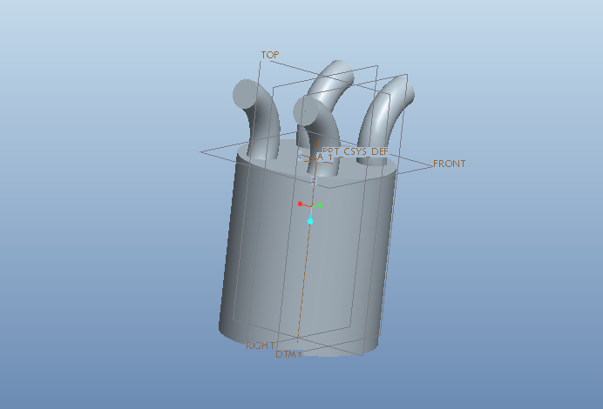
Fig 3.3
2d model
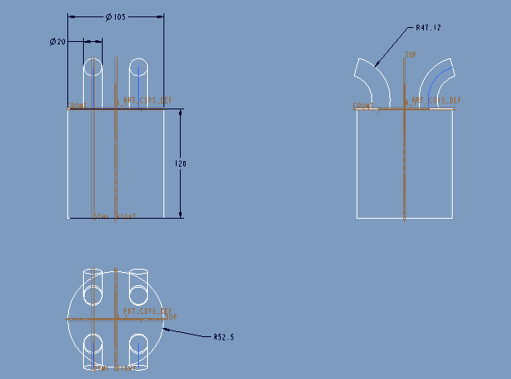
Fig 3.4
3.1.2. Grid independence & Validation study
Computational fluid dynamics, usually abbreviated as CFD, is a branch of fluid mechanics that uses numerical methods and algorithms to solve and analyze problems that involve fluid flows. Computers are used to perform the calculations required to simulate the interaction of liquids and gases with surfaces defined by boundary conditions. With high-speed supercomputers, better solutions can be achieved. Ongoing research yields software that improves the accuracy and speed of complex simulation scenarios such as transonic or turbulent flows. Initial experimental validation of such software is performed using a wind tunnel with the final validation coming in full-scale testing, e.g. flight tests.

Methodology
In all of these approaches the same basic procedure is followed.
During preprocessing
- The geometry (physical bounds) of the problem is defined.
- The volume occupied by the fluid is divided into discrete cells (the mesh). The mesh may be uniform or non-uniform.
- The physical modeling is defined – for example, the equations of motion + enthalpy + radiation + species conservation
CFD ANALYSIS
→→ Select mesh on work bench → right click →edit → select mesh on left side part tree → right click → generate mesh →

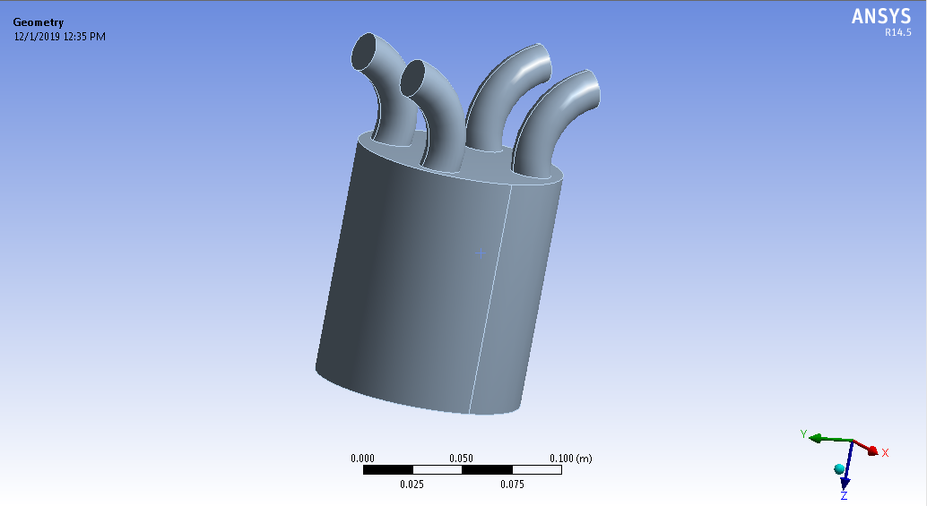
Fig 3.5

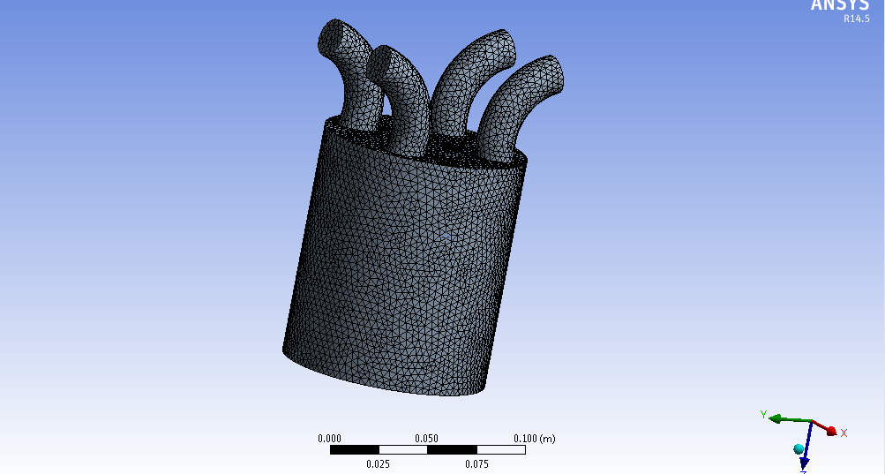
Fig 3.6
The model is designed with the help of pro-e and then import on ANSYS for Meshing and analysis. The analysis by CFD approach is used in order to calculating pressure profile and temperature distribution. For meshing, the fluid ring is divided into two connected volumes. Then all thickness edges are meshed with 360 intervals. A tetrahedral structure mesh is used. So the total number of nodes and elements is 21264and 109297.
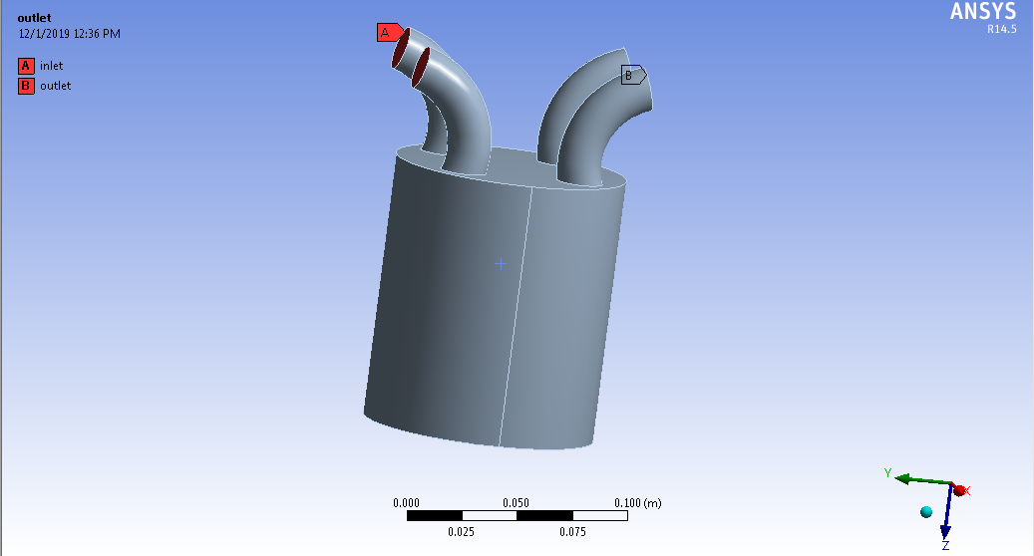
Fig 3.7
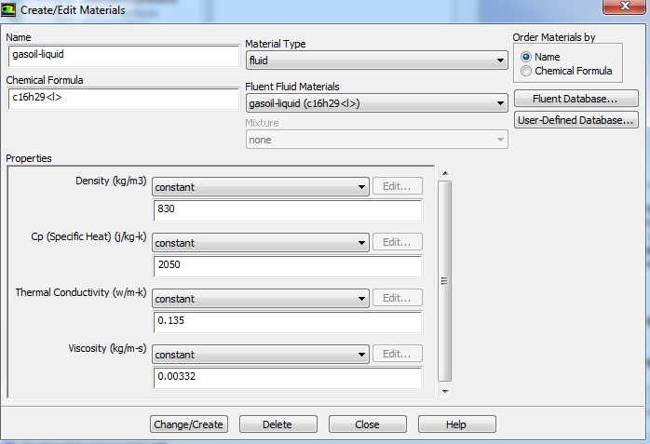
Fig 3.8

3.1.3 Boundary conditions
Boundary conditions>inlet>enter required inlet values-at engine speed-1500 rpm –mass flow arte is 0.0011054 kg/sec
Solution > Solution Initialization > Hybrid Initialization >done

Results:
edit>select contours>ok>select location (inlet, outlet, wall.etc)>select pressure>apply

Pressure counters
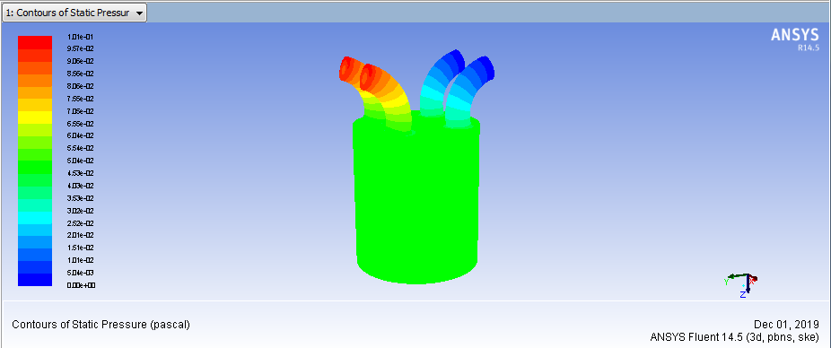
Fig 3.9

Velocity counters
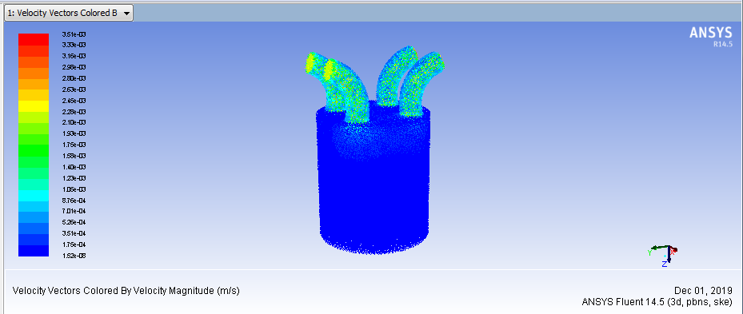
Fig 3.10
Heat transfer coefficient
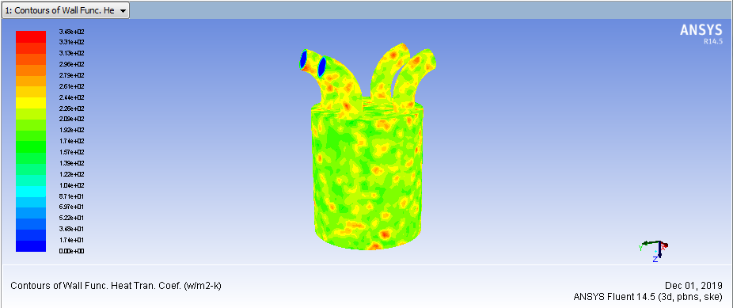
Fig 3.11

Mass flow rate
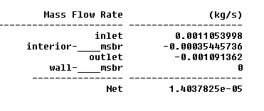
Heat transfer rate
